Macroinvertebrates (Full Report)

Miroslav Očadlík1, 2, Margita Lešťáková2, Béla Csányi3, Emília Mišíková Elexová2, Marek Svitok4, József Szekeres5, András Weiperth6 & Momir Paunović7

1 WWF Slovakia, Medena 5, 811 02 Bratislava, Slovakia

2 Water Research Institute, Nab. arm. gen. L. Svobodu 7, 812 49 Bratislava, Slovakia

3 Budai Nagy Antal utca 10, Göd 2131, Hungary

4 Faculty of Ecology and Environmental Sciences, Technical University in Zvolen, T. G. Masaryka 24, 960 01 Zvolen, Slovakia

5 Centre for Ecological Research, Dpt. of Danube's Diversity, Karolina ut. 29, 1113 Budapest, Hungary

6 Hungarian University of Agriculture and Life Sciences, Dpt. of Freshwater Fish Ecology, Pater Karoly ut. 1, 2100, Godollo, Hungary

7 Institute for Biological Research, Bulevar despota Stefana 142, 11060 Belgrade, Serbia

**ABSTRACT**

Benthic macroinvertebrates were sampled by national experts during the JDS4 campaign in the first weeks of July with five different sampling approaches. Samples from Multi-Habitat Sampling (MHS) were completely analysed and used for Indicative Status Assessment (ISA). National experts with help of external experts processed and identified MHS samples according to JDS4 MZB Methodology. In the majority of cases, only one side of the river was selected for sampling, though at transboundary sites, both sides were usually sampled. In total, 484 taxa were found belonging to 19 higher taxonomical groups, 394 taxa were found in the Danube River and 287 taxa in tributaries. For definition of water quality, the Saprobic index and Slovak Multi-metric Index were used for indication of responds of macroinvertebrates assemblage to both effects of pollution and changes in hydromorphology. A brief discussion is given about the sampling efficiency of additional sampling methods concerning the successful detection of Unionidae mussels and Decapoda species.

# INTRODUCTION

Benthic macroinvertebrates are the most widely used indicator group for lotic systems (Moog et al., 2018). These organisms, when used in such investigations, offer several benefits including easy identification at high taxonomic levels by non-specialists, high sensitivity of a great number of species to environmental stress, a wide distribution in various freshwater habitats and a relatively sedentary behaviour and short life cycle, in comparison to fish, which facilitate the detection of changes over time (Johnson et al. 1993).

The following subchapters describe the methods applied; the characteristics of the macroinvertebrate community along the Danube River and its tributaries and show resulting ISA and Saprobic index compared with previous JDS2 (2007), JDS3 (2013) and national assessment results.

# METHODS

## Sampling Methods

The JDS4 monitoring campaign for benthic macroinvertebrates was carried out by national teams while the Core team of international experts had a coordinating and advisory role to ensure the coherence between the approaches used by the national experts.

Based on the experiences from the previous Joint Danube Surveys, five different approaches were applied:

### Main approach:

**Multi-Habitat-Sampling (MHS)** – used as a standardized WFD sampling method for the ecological status assessment (AQEM Consortium, 2002) was effective for ecological status assessment of wadable rivers – or large rivers at lower water period (Graf et al. 2015).

Method is described in details in JDS4 MZB Methodologyfor BQE Aquatic Macroinvertebrates (ver. 6.5). Benthic macroinvertebrate samples for taxonomical identification were collected using a hand-net from all available microhabitats by kicking or disturbing the substrate. Together 20 sampling units (replicates) were taken from all major microhabitats with coverage above 5%. In case of interesting or important microhabitats (e. g. Xylal) with coverage less than 5%, one additional replicate was taken (so-called sample 21st). Results of Multi-Habitat-Sampling were used for ISA and taxa richness overview.

### Additional approaches:

**Kick and sweep (K&S)** – was proposed in order to provide additional data on biodiversity (specifically related to molluscs), as well as to provide full comparability with previous surveys and input to activity related to invasive species.

**Deep-Water Dredging (DWD)** – sampling in deep water regions using motor boats and dredges was used particularly to collect bottom material and taxa occupying the deep-water habitats. The procedure enables the more effective data collecting in the non-wadeable part of the river that actually covers majority of the river bed at any given cross section (mostly relevant for the lower Danube River).

**Additional effort for Mussel Sampling (AMS)** – an additional method was used for collecting reliable information on Unionidae mussel species relevant for collection of IAS data, and mussel specimens for PAHs analyses.

**Specific sampling for crayfish (LiNi )** – an additional method for collection of reliable information on this important component – comparable data almost completely missing. A combination of sampling methods on the Hungarian Danube, including **elecdtrofishing** and **hand search** was experimentally performed for providing more confident information on Invasive Alien Species (IAS), as well.

Methods are described in detail in full report and Standard Operational Procedures (SOP) for MZB and Invasive Alien Species (available on [www.danubesurvey.org/jds4](http://www.danubesurvey.org/jds4)).

Total number of 46 JDS4 sampling sites were planned for macroinvertebrates sampling. Due to high water levels, sampling was postponed (to end of September) in case of River Inn at Passau-Ingling (JDS4-5-L) below power station. Sampling site Timok mouth (JDS4-42; 0.2 r. km) was sampled but no living organisms were found. From all five sampling approaches, only MHS was used for the diversity overview and ISA, samples from other approaches were processed partially and used for neozoa and molluscs study. Out of 45 JDS4 sites, 35 sites were sampled at one river side/bank and 10 at both sides/banks (explained in paragraph 2.2). Hence, 55 samples were totally collected.

For ensuring data comparability, external experts for selected MZB groups (Tab. 1) were involved. List of experts was approved by the ICPDR: Igor Kokavec (Oligochaeta), Dubravka Čerba, Nataša Popović, Djuradj Milošević (Chironomidae, Diptera), Béla Csányi (Mollusca), Jelena Đuknić (Simuliidae, Diptera), Stefan Anđus (Porifera) and Péter Borza (Crustacea).

Table 1. Problematic groups from MHS samples/country which have been identified by external experts (marked “●”)

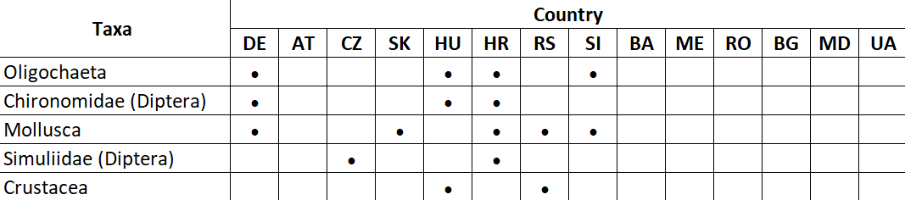

## Metrics and Indicative Status Assessment (ISA) Method

Only one river side was selected for sampling. In case of transboundary sites, both river sides were usually sampled. Sampling sides have been agreed based on bilateral negotiations. Each side (left or right bank) was considered and assessed as a separate sample.

### Multi-metric Index (MMI)

Slovak national method for large rivers (Makovinská et al. 2015) was used for the ISA and already tested with prior Austrian Danube data providing reasonably results (Leitner, 2013). Relevant metrics were selected for rivers in altitude below 200 m a.s.l. and between 200 – 500 m a.s.l. (Tab. 2). Internal Water Research Institute software INFOSYS based on ASTERICS ver. 4.0.4 was used for calculation of metrics and Indicative status final evaluation. List of taxa with quantitative values (density per 1.25 m2) represent the basic data for the calculation of the metrics. After transforming the values of the metrics to EQRs, their average value is calculated, which represents the resulting multimetric index. Based on value of this index (in the range 0 – 1) relevant Indicative status class was evaluated.

### Saprobic indices (SI)

SI were calculated based on available national method, using ASTERICS 4.04 and EcoProf 5.0 software. National methods (DE, AT, SK) for calculation of the SI were used on JDS4 sampling sites 1 - 10, 13, 14, 19, 20, 21; on sites 11 and 12 – Slovak SI and on sites 34, 35, 36 Croatian HR-SI were applied. Romanian SI was applied for the other tributaries and sites which were located at Middle and Lower Danube River reach.

For the indication of quality classes, threshold values given in Tab. 3 were applied (Bujis, 2006). For Upper Danube River reach and tributaries (sites 1 – 8), national classification was used. In Germany the reference value is 1.85 for national type 10 (Rolaufs et al. 2003). In Austria the reference conditions are defined as 1.75 for ecoregion 9 and 2.0 for ecoregion 11 (changing between sites 8 and 10) (Stubauer &Moog, 2003). Value 2.0 was used as the saprobic basic conditions for the middle and lower Danube River and its tributaries.

Table 2. Metrics used in Slovak national assessment method

|  |  |  |  |  |  |  |  |  |
| --- | --- | --- | --- | --- | --- | --- | --- | --- |
| **Large rivers at altitudes (m)** | **Metrics** | | | | | | | |
| Saprobic index  (Zelinka &Marvan) | (%) Oligosaprobic classified taxa (scored taxa = 100%) | BMWP | Rhitron Type Index (Biss et al., 2002) | Index of biocoenotic regions (IBCR) | (%) preferences for akal+lithal+psammal (scored taxa = 100%) | (%) Metarithral classified taxa (scored taxa = 100%) | EPT (number of taxa) |
| < 200 | • | • | • | • | • | • |  |  |
| 200 - 500 | • | • | • | • | • | • | • | • |

Table 3. Range of Saprobic Index

|  |  |  |  |
| --- | --- | --- | --- |
| **Status class** | **Saprobic reference condition** | | |
| Germany national type 10 | Austria Saprobic basic condition 1.75 | Austria Saprobic basic condition 2.0 |
| I - High | 1.75 - 1.85 | ≤ 1.75 | ≤ 2.00 |
| II - Good | 1.86 - 2.30 | 1.76 - 2.21 | 2.01 - 2.40 |
| III - Moderate | 2.31 - 2.90 | 2.22 - 2.68 | 2.41 - 2.80 |
| IV - Poor | 2.91 - 3.45 | 2.69 - 3.14 | 2.81 - 3.20 |
| V - Bad | > 3.45 | > 3.14 | > 3.20 |

### Statistical Method

Ordination and classification methods were used to gain insight into variability of invertebrate communities along the Danube River. Principal coordinate analysis (PCoA) using matrix of Hellinger distances was employed to extract main compositional gradients. Longitudinal zones across which the invertebrate communities changed markedly were identified using stratigraphically constrained incremental sum of squares cluster analysis (CONISS, Grimm, 1987). Broken-stick model was used to determine significant number of zones in the cluster analysis (Bennett, 1996). For the multivariate analyses, data from left and right bank of the river were pooled within sites (Fig. 1).

We performed PCoA on a whole data set and also separately for six major taxonomic groups with more than 15 species recorded (Oligochaeta, Mollusca, Crustacea, Ephemeroptera, Diptera, Trichoptera). This allowed us to compare overall zonation with zonation patterns revealed by individual groups. Beside the qualitative comparison, we performed Procrustes analysis to quantify how well composition gradients of individual taxonomic groups match with overall community composition. The analysis was corroborated by randomization test based on 9,999 permutations (Peres-Neto & Jackson, 2001) (Tab. 4).

PCoA was also used to visualize differences in community composition between communities sampled at left and right banks. Only the sampling sites with both banks sampled were used in this analysis.

Table 4. Correlations of differences in the composition of the whole assemblage (All) and individual groups. Statistically significant correlations highlighted in bold.

|  |  |  |  |  |  |  |  |
| --- | --- | --- | --- | --- | --- | --- | --- |
|  | All | Mollusca | Diptera | Crustacea | Ephemeroptera | Trichoptera | Oligochaeta |
|  |  |  |  |  |  |  |  |
| All | - | **0,001** | **0,001** | **0,006** | **0,045** | 0,391 | **0,001** |
| Mollusca | **0,63** | - | 0,065 | 0,247 | **0,003** | 0,255 | **0,016** |
| Diptera | **0,72** | 0,34 | - | 0,080 | 0,112 | **0,012** | **0,001** |
| Crustacea | **0,47** | 0,27 | 0,35 | - | 0,080 | 0,102 | **0,007** |
| Ephemeroptera | **0,38** | **0,47** | 0,32 | 0,33 | - | 0,580 | **0,030** |
| Trichoptera | 0,39 | 0,27 | **0,43** | 0,33 | 0,20 | - | **0,006** |
| Oligochaeta | **0,77** | 0,42 | **0,65** | **0,48** | **0,38** | **0,42** | - |

# RESULTS and DISCUSSION

## Diversity and density from Multi Habitat Sampling (MHS)

During the JDS4 sampling campaign, in total, 484 aquatic macroinvertebrate taxa were found in 55 samples (Annex 1). Altogether 394 taxa were found in the Danube River and 287 taxa in tributaries (Inn, Dyje, Morava, Moson Danube,Vah, Hron, Ipel, Ráckevei, Drava, Tizsa, Sava, Velika Morava and Prut).

The most diverse groups were Diptera (160 taxa) and Oligochaeta (53), followed by Trichoptera (42) and Gastropoda (41) then Crustacea (32), Ephemeroptera (30), Bivalvia (28), Coleoptera (25) and Odonata (22). Heteroptera (12), Hirudinea (9) and Turbellaria (5) are less heterogeneous groups. Other groups were even less diverse. Nematodes well identified at species level (11 taxa) only by Bulgarian national experts and were excluded from diversity and statistical analyses as they are not considered as a typical benthic macroinvertebrates (often categorized as microinvertebrates) and also for comparison purpose.

Focusing only at the Danube River reaches (Upper Danube River: from source to rkm 1790, Middle Danube River: from rkm 1790 – 943, Lower Danube River from rkm 943 to mouth; Tab. 7), most diverse groups are as follows: Diptera (130 taxa), Oligochaeta (40), Trichoptera (37), Mollusca (Gastropoda 36 taxa, Bivalvia 23 taxa), Crustacea (29), Ephemeroptera (23), Coleoptera (20) and Odonata (13). Along the Danube River reaches, EPT (Ephemeroptera, Plecoptera & Trichoptera), Coleoptera and Bivalvia taxa are decreasing in diversity. On the contrary, Oligochaeta together with Gastropoda were increasing in heterogeneity (Fig. 2).

Other groups are constant. Less than 10 taxa were recorded on sampling sites 29-L and 41-R and less than 6 taxa were examined on sites 23-L and 28-R in total. Cluster analysis of Danube River samples shows MZB assemblage changes in longitudinal gradient (Fig. 1).

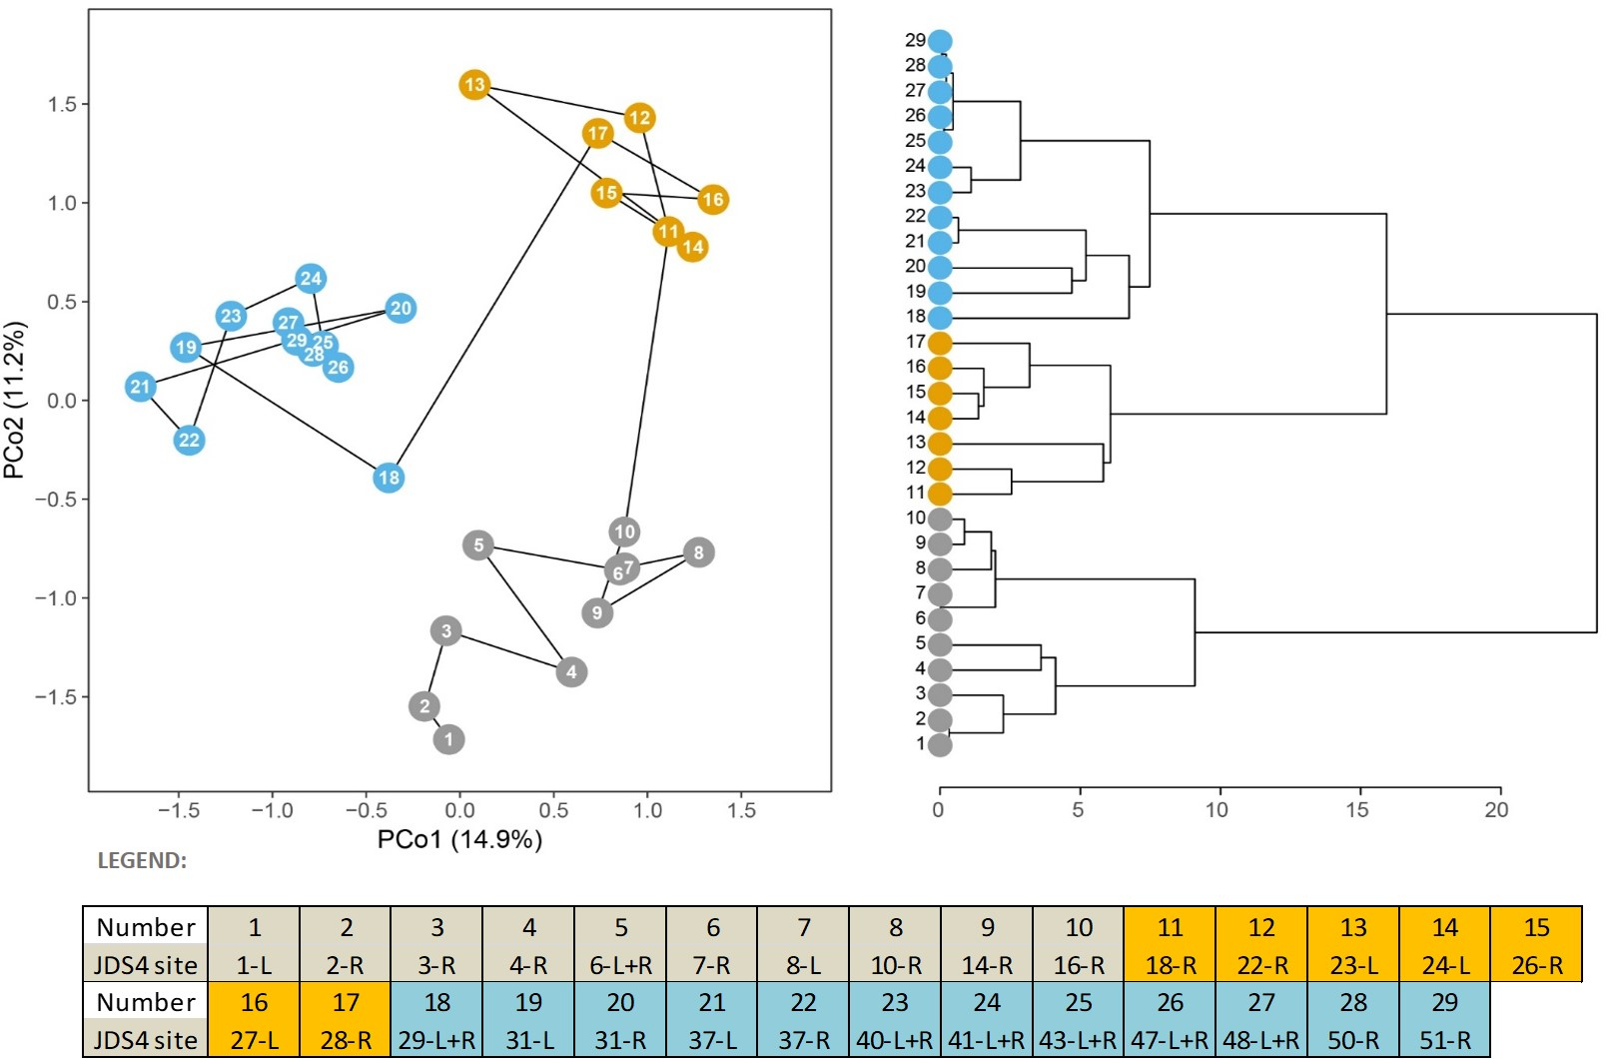

Figure 1. PCoA ordination plot (left) and CONISS dendrogram (right) of invertebrate communities (only Crustacea, Diptera, Ephemeroptera, Mollusca, Oligochaeta and Trichoptera could be used; data from left and right bank were merged). Significant zones are highlighted in different colours. Variance explained by the ordination axes is given in parentheses.

As the slope of the river determines the flow velocity, the bed material and benthic communities gradually change. Analysis indicates 3 separate sections (Fig. 1), and the boundary between upper and middle section (16-R Medveďov / 18-R Gönyű) is similar to the pre-defined upper and middle Danube River boundary where the first decrease of bed slope occurs. This is identical with the boundary between Danubian and Pontocaspian fauna (Brtek, 1953). However, the analysis shows that the boundary between the middle and lower section has shifted upstream in comparison to the generally accepted middle/lower Danube reach situated after the Iron Gate I. According to the multivariate analysis of JDS2 macroinvertebrate dataset a similar result was found: the Middle Section of the Danube river ends up in Hungary between Paks (site 27, 1532 rkm) and Baja (site 28, 1480 rkm) (Csányi, in verb). The explanation is given by the change in substrate composition due to another characteristic decrease of the bed slope: gravel is evidently changed to to smaller fraction (sand) that is illustrated well by the composition of aquatic biota. According to the JDS4 results only the Slovakian-Hungarian and the Hungarian Danube represents the Middle Section Type.

Differences in invertebrate community composition between left and right banks of the river were sometimes as large as differences among the sampling sites (Fig. 3, right). The variation within sites could be attributable to different habitat composition and/or to influence of tributaries. When compared to the results from JDS3, a similar diversity pattern occurred, however, the number of taxa of Gastropoda groups found during JDS4 has doubled. On the other hand, several Ponto-Caspian species native to the lower Danube River stretch found during JDS3 were now seen to be missing. In addition, species from genus *Pisidium* sp. are completely missing in the taxalists from the middle and lower reaches.

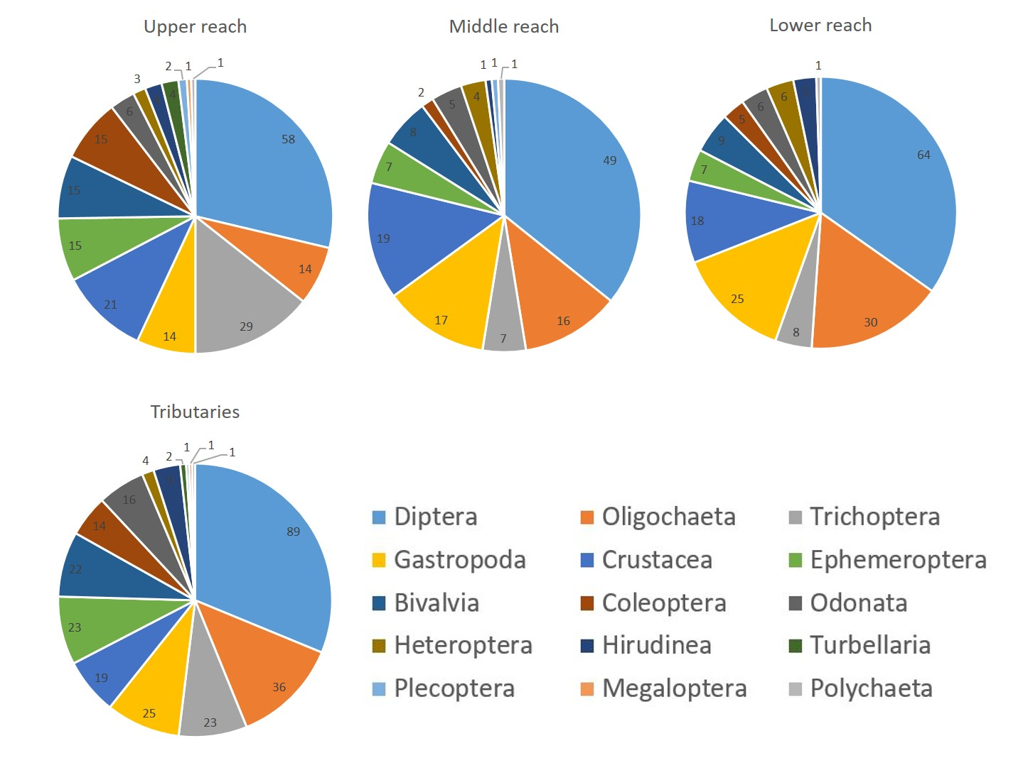Figure 2. Number of taxa per taxagroup in upper, middle and lower reach of the Danube River and its tributaries.

In terms of total density (number of ind./1.25 m2), groups Crustacea and Gastropoda followed by Oligochaeta and Diptera (mostly Chironomidae) (Fig. 3, left) are the most dominant part of the benthic macroinvertebrates assemblage.

Along the Danube River longitudinal profile, density of Coleoptera, Ephemeroptera, Trichoptera, Gastropoda and Polychaeta is decreasing. Large rivers are one of the freshwater ecosystems most affected by hydrologic alternation, bank modification, pollution and navigation. EPT taxa in particular, are highly sensitive. However, in the case of JDS4, diversity of these particular taxa could be affected also by the sampling season (late summer). Some National experts noticed a higher water level before and during the sampling campaign.

This could affect the density and diversity of the benthic macroinvertebrates assemblage as flood flow was referred to decrease of Annelida, Ephemeroptera, Trichoptera, Coleoptera and Plecoptera groups in general (McMullen & Lytle, 2012).

Polychaeta represented only by *Hypania invalida* occurred mostly in the upper reach. On the contrary, Heteroptera increased in density from the upper to lower Danube River. Taxa of Gastropoda and Oligochaeta that suits flat banks with sandy and muddy sediments show a peak in the middle reach. Crustacean *Chelicorophium chelicorne* was not found during JDS1/2/3 campaigns, and it is surprising that it had been present in such high numbers during JDS4 as reported in 50-R and 51-R sites.

The rare species, *Theodoxus transversalis* was reported only at site 48 (Chiciu/Silistra, rkm 375) on the Lower Danube probably due to the high water level. It was detected at several Lower Danubian sites during previous surveys (JDS2 and JDS3) but additional methods (K&S and particularly deep-water dredging was necessary for the successful detection of this characteristic Danubian snail species..

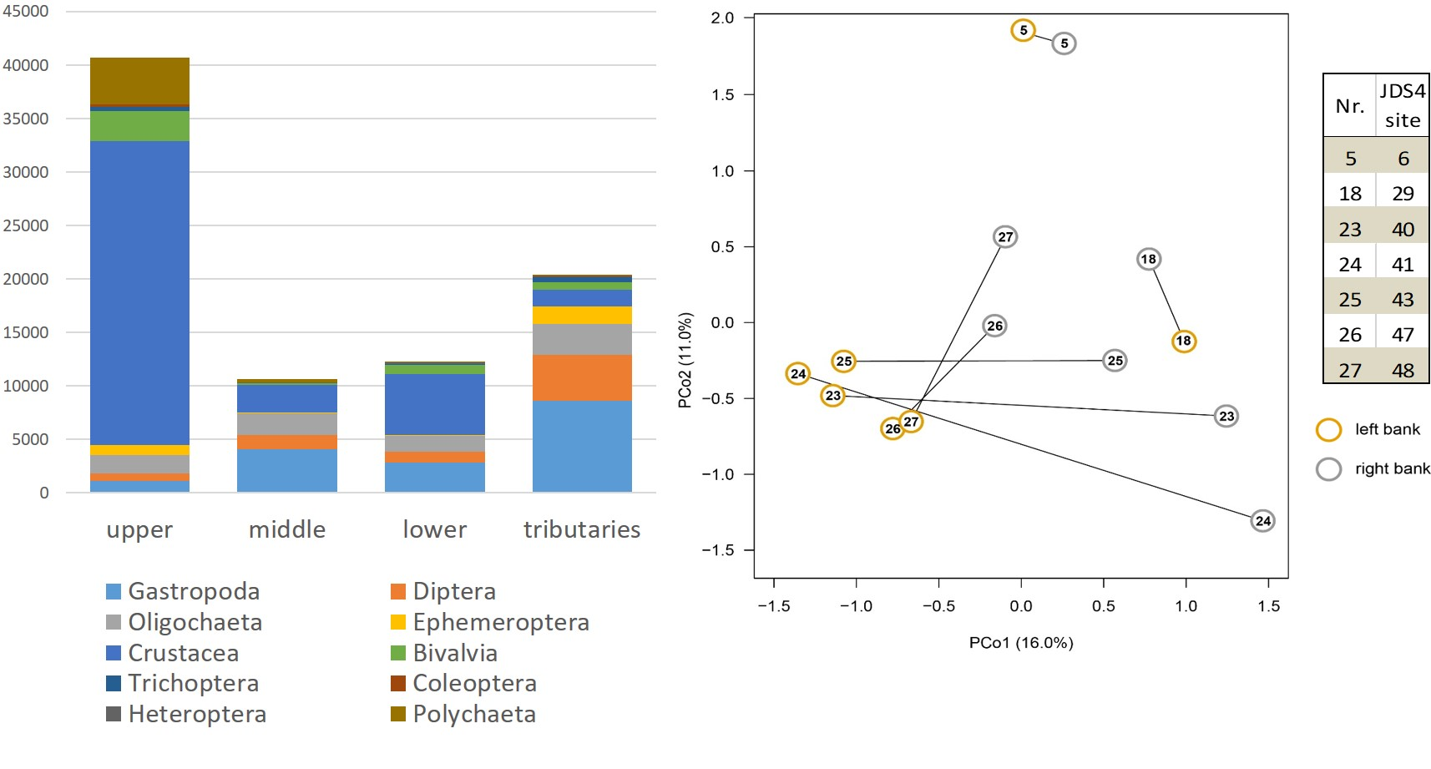Figure 3. In left: Density per taxagroup (ind./1.25 m2) in upper, middle and lower reach of the Danube River and in tributaries (only most abundant groups); Right: PCoA ordination plot showing differences in community composition between left and right sides (banks) of the same sampling sites. Variance explained by the ordination axes is given in parentheses.

A new Hydrobiid snail species was found in the Hungarian-Slovakian section: *Clathrocaspia knipowitschii* was detected at first during the JDS3. The sail was present along the whole cross section of the Danube at downstream Iron Gate I in deep-water dredged samples and one specimen was found in Kozlodui, as well. During JDS4 the presence of this species was proven at Gönyű and eDNA method detected it in Medve/Medvedov, too. The example of these two snail species illustrate well that the study of deep-water habitats using appropriate sampling procedure is important also.

In tributaries, Gastropoda is the most dominant group, followed by Diptera and Oligochaeta group. Compared to the Danube River reaches, Diptera represent principal part of the community, represented mainly by the family Chironomidae.

## The method for Unionidae species

Unionidae species are characteristic members of the Danube River. Usually, it is very difficult to find individuals along the river due to the seldomly distributed mussel habitats. Hence a method using **additional effort** was necessary to apply for discovering these animals along the river bed and to determine the size of their population.

The meaning of additional efforts is to collect mussels in field using the so called "full body contact" method: going directly in the water looking for those habitats that we think mussels should be there and touching the bottom carefully by hand, searching the bottom for mussel individuals. The whole procedure consists of two phases:

1. Visual identification of suitable habitats at the sampling sites;

2. Searching for mussels at the sites by tactile sensing of them.

Based on the experiences of the Cousteau-Expedition (1991-92) conducted along the entire length of the Danube River it is clear that these habitats are "quasi-stationary" locations where the river bottom provides appropriate living and existence conditions for mussels on a long-time scale for their colonization. Our basic recognition concerning mussel occurrences in the Middle Danube is that Unionids can usually colonize successfully the transition zones of lenitic and lotic habitats of river sections where the stability of bottom provides perfect survival conditions for mussels: neither extended bed erosion nor serious sedimentation occurs along this type of river section.

Discovering the appropriate location, it is necessary to go under the water by free lung diving and look for mussels directly by hand searching on the bottom. Therefore, the best season for such kind of "on-site" field observation is the summer period when warmer water temperature and low water conditions exist. Sufficient field experience allows the recognition of the shape of the shell and identification of mussel species under the water based on touching it (only seven Unionidae species live in the Danube).

## Comparative analysis of four methods for exploring Unionidae mussel stocks

Across the whole investigated Danube River, Unionidae mussels were detected only at 10 sites where altogether 4 species and 64 individuals were found (Fig. 4). MHS and K&S method indicated that *Sinanodonta woodiana* is the dominant species on the entire Danube River. It is important to note that this finding is based on a very special dataset: 27 individuals of this non-indigenous species were found on the Danube (3 on the tributaries) and 20 of them was described from Bazias (left, Romanian side) in one AQEM sample. This value overweigth the general results of Unionidae collected by MHS.

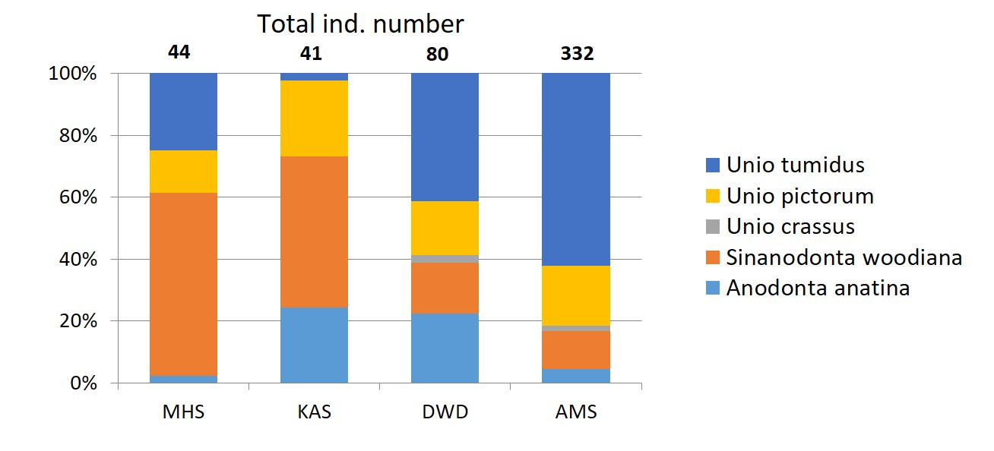Figure 4. Species composition and abundance of detected Unionidae stock by different sampling procedures along the Danube River during JDS4. Note that MHS and KAS refer to the entire Danube whereas DWD and AMS was done only on the HU-RS section (Total ind. number = total caught animals per method).

Beside of MHS and K&S the Deep-Water Dredging (DWD) and the Additional Effort for Mussel Sampling (AMS) was performed on the **Hungarian and Serbian Danube section**, on the 942 river km long stretch at 17 sampling sites. The AMS method provided much higher numbers of collected individuals than any of the other three methods. There is no doubt that neither MHS nor K&S could give realistic and reliable information about species composition and abundance. Altogether only six individuals of three species were found by MHS at three sampling sites of seventeen. K&S procedure proved the presence of four species and twelve individuals at five sites. DWD detected all of the registered five species but only at seven sites, altogether 35 individuals were detected in the samples. However, AMS resulted in an expressive value: 332 mussel individuals of five species were found at 13 sampling sites (Fig. 5).

The indication of species composition and abundance by different methods is interesting also. *Unio crassus* and *Anodonta anatina* were not found by MHS method. K&S indicated the overall dominance of *Sinanodonta woodiana* but only twelve individuals of Unionidae were detected by this method. Relatively many of *Anodonta anatina* specimens were present in the dredged samples among 35 individuals. AEM sample showed finally the realistic species composition of the investigated Middle and part of the Lower Danube section (Fig. 5) showing the overall dominance of *Unio tumidus* detecting more than 300 specimens.



Figure 5. Results of four mussel sampling methods on the Hungarian-Serbian Danube during JDS4. Yellow: *Anodonta anatina*; red: *Sinanodonta woodiana*; green: *Unio crassus*; ligth blue: *U. pictorum*; dark blue: *U. tumidus*.

The example of JDS4 illustrates that the use of Additional Effort method was necessary to clarify the real abundance and species composition of the Unionidae mussels in the Middle Danube. There is another finding of the JDS4 program: it is very important to know the physiognomy and hydraulic character of the investigated river during such surveys in order to predict the suitable habitat pattern of the given river sections where mussel sampling is planned.

Two conclusions should be emphasized:

1. Effective detection of different organisms could vary on a wide scale, particularly in large and very large rivers due to the rare availability of appropriate habitats. New species-specific sampling approach could help to increase the detection effectiveness;

2. Particular attention is necessary for appropriate design of sampling locations in case of longitudinal surveys along large and very large rivers for reliable data collection. Bed stability plays central role in the successful colonization and survival of mussels. The best habitats can develop in transitional zones between lenitic and lotic sites. The transition could happen from upstream to downstream (flow velocity decreases parallel to the flow direction), or, from littoral to deep bed, forming a zone where the transition is perpendicular to the length of the river (flow velocity increases with depth).

## Sampling of Decapoda species

Beside of the regular LiNi crayfish trap sampling two additional methods were applied on the Hungarian Danube section during two seasons, summer and autumn:

• Electrofishing (EF);

• Hand searching (HS).

The application of additional methods provided more reliable dataset concerning the detection of non-indigenous Decapoda species on this investigated Danube stretch (Tab. 6, Fig. 6). Although *Procambarus clarkii* was found only downstream of Budapest by LiNi (three specimens at summer and two at autumn), hand searching detected this new North American species at Paks, 120 km from Budapest downstream, as well. EF and HS were able to catch much more animals than LiNi: 61 individuals in summer and 77 in autumn. Altogether four Decapoda species were detected in the Hungarian Danube section, 242 in summer and 248 in autumn, respectively. Out of these numbers LiNi trap detected 17 of them in summer and 18 in autumn period indicated the necessity of using more sampling methods for Decapoda surveys. This conclusion is very similar to the outcome of the comparative mussel sampling program performed on the Hungarian-Serbian Danube section.

Table 5. Number of caught Decapoda species by three methods during JDS4 on the Hungarian Danube.

|  |  |  |  |  |
| --- | --- | --- | --- | --- |
| **Summer** | | | | |
|  | LiNi | EF | HS | **Individual number of species** |
| *Faxonius limosus* | 12 | 74 | 63 | **149** |
| *Pacifastacus leniusculus* | 1 | 6 | 9 | **16** |
| *Procambarus clarcii* | 3 | 19 | 42 | **64** |
| *Pontastacus leptodactylus* | 1 | 7 | 5 | **13** |
| **Summ of animals per method** | **17** | **106** | **119** | **242** |
|  |  |  |  |  |
| **Autumn** | | | | |
|  | LiNi | EF | HS | **Individual number of species** |
| *Faxonius limosus* | 9 | 64 | 60 | **133** |
| *Pacifastacus leniusculus* | 3 | 6 | 9 | **18** |
| *Procambarus clarcii* | 2 | 31 | 46 | **79** |
| *Pontastacus leptodactylus* | 4 | 5 | 9 | **18** |
| **Summ of animals per method** | **18** | **106** | **124** | **248** |
|  |  |  |  |  |

Figure 6. Detected Decapoda species by different sampling methods (LiNi: traping; E-F: electrofishing; H-S: hand search).

Summarizing the results of the two seasonal surveys using three different sampling methods a very comprehensive picture can be drawn about the present invasive situation on the Hungarian Danube. *Faxonius limosus* dominates the overall population (Fig. 7).

Figure 7. Relative abundance of Decapoda species in the Hungarian Danube section based on data of three sampling methods and two sampling periods.

Based on data of three sampling methods and two sampling periods at present the native *Pontastacus leptodactylus* population forms only 6.33% of the total abundance. This time more than the half of the total catch consists of *Faxonius limosus* and more than the quarter belongs to *Procambarus clarkii*.

### Longitudinal distribution based on three methods

As it is proven during JDS4, non-indigenous species are very frequent elements nowadays in the Hungarian Danube section. It is interesting new information that *Procambarus clarkii* has extended distribution from Budapest downstream to Paks. Hand searching provided most of this species (72 specimens downstream Budapest). *Faxonius limosus* is present in all investigated cross section being the most frequent invasive crayfish in the Hungarian Danube. The largest population size was experienced in the Ráckevei-Soroksári Danube arm (RSD). However, it seems that *Pacifastacus leniusculus* started to populate the upper Danube downstream because recent research detected its presence at several new sites around the Szigetköz area (Weiperth et al. 2020, personal communication).

To carry out such a detailed survey using several sampling methods is very much advisable in other Danubian countries in order to follow the spread of the new non-indigenous Decapoda species along the river. It is the good news for now that - according to the data of all methods - the native *Pontastacus leptodactilus* is still present at the investigated Upper and Lower Danube in Hungary, though in very low density.

## Indicative Status Assessment (ISA) based on Multi-metric Index (MMI) and Saprobic Index (SI)

The saprobic system takes into account the varying sensitivity of the macrozoobenthos species to oxygen depletion in particular. Water quality class expressed by SI is derived from the individual saprobic values assigned to bioindicators occurring in assessed water environment.

Indicative status assessment (ISA) is assessment based on one sampling event only, and results are neither aimed to replace nor influence national assessment, but rather to serve to compare situations along the investigated stretch of the Danube river and its tributaries.

Along the Danube River reaches (36 samples in total), 24 samples (67%) can be classified into good status, 5 samples (14%) into high status, 4 samples (11%) to moderate and 3 samples (8%) fall into the poor status. Compared to the JDS3 and JDS2, results are similar, however Graf et al. (2015) note the differences between Airlift and MHS results. Besides that, at the banks the conditions can be different and can even vary between right and left bank, what can be seen at sites (37, 40, 41, 48) (Fig. 3, right).

In the case of samples from tributaries (19 samples), the situation is as follows: 13 (68%) samples can be classified into good status, 4 (21%) to moderate and 2 samples to poor status (Tab. 7). Results from the Danube River using MMI show good indicative class in 13 samples, moderate class in 11 samples and poor class in 10 samples (Tab. 7).

In two sites, high status was indicated: 2-R Bittenbrunn, where the highest diversity was documented and 29-L Hercegszanto/Batina/Bezdan, where surprisingly only 8 taxa were found (status based on BMWP index was 4) and therefore the overall indicative status for this site cannot be considered as fully reliable.

Table 6. **Indicative status assessment**: Saprobic index class (SI) and Slovak MMI status class (SK) for the Danube River sites with results from JDS2 (only Saprobic index class, Airlift sampling method) and JDS3 (MHS method) - Saprobic index class and Slovak MMI compared to **National assessment**: DE – national intercalibrated MZB assessment tool Perlodes; AT, SK, HU, HR, RO and BG – national methods applied on JDS4 data (* samples were note taken under the best possible conditions).

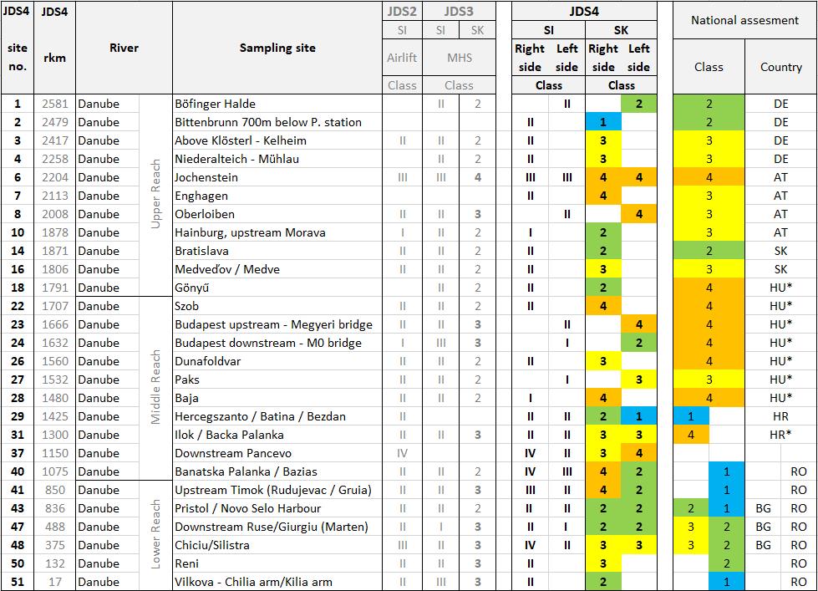

From the tributaries, 8 samples fall in moderate class, 5 samples into poor class, 4 samples to good class and 2 samples achieved high class (Tab. 7). These results are not plausible and lead us to conclusion that the Slovak method should not be used for the ISA in tributaries, as seen especially in cases of Velika Morava and Sava Rivers, with high variance of classes within their longitudinal stretches (Tab. 7).

Table 7. **Indicative status assessment**: Saprobic index class (SI) and Slovak MMI status class (SK) for the Danube tributaries with results from JDS2 (only Saprobic index class - Airlift sampling method) compared to **National assessment:** CZ – intercalibrated MZB assessment; SK, HR, SI and RO - national methods applied on JDS4 data.

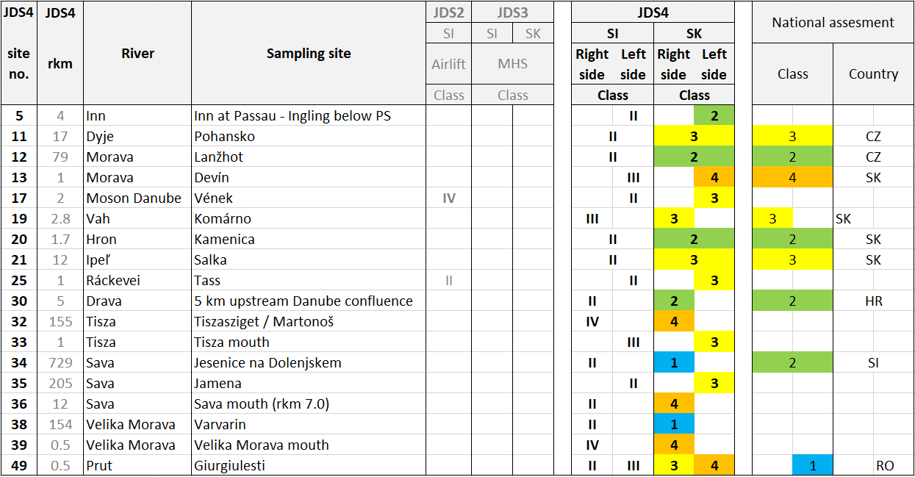

# CONCLUSIONS

Change in substrate composition of the Danube River induce gradual benthic community shifts from rheophilous to potamophilous in longitudinal profile. Based on cluster analysis of MZB assemblage from the Danube River samples, three sections have been identified: upper/middle section between sampling sites 16 (Medveďov, rkm 1806) and 18 (Gönyű, rkm 1791) and for middle/lower section with boundary between sites 28 (Baja, rkm 1480) and 29 (Batina, rkm 1425).

The saprobity of the Danube River and its tributaries varied between water quality class I, II, III and even IV. However, in some cases, number of bioindicators found was too small for valid interpretation or conclusions.

Despite the assessment approach being very similar, the indicative status shows generally worse conditions (roughly by one class) when compared to JDS3 results. This could be caused by different sampling methodology (sampling from one river bank was preferred) which reduced the number of sensitive taxa and, in some cases, the higher water level increased bed load movement and could affect benthic communities, leading the recolonization of habitats to take longer.

Slovak Multi-metric index seems not to be suitable for the tributaries’ assessment. Hence, the large tributaries along the Danube River deserve their own particular approach. For the next JDS, assessment methods should be tested on JDS4 data from main channel and tributaries separately.

For ensuring best results, both river banks should be sampled. The application of different sampling methods always provide better data in several aspects, however from a practical point of view, national teams should focus only at one main sampling technique (e.g. MHS or DWS in the lover Danube River reach). Assistance of external experts with most problematic groups, e.g. Oligochaeta and Chironomidae (Diptera), could be recommended for each participating country. This will ensure data comparability (especially for statistical methods) of the most abundant groups.

# REFERENCES

AQEM consortium (2002). Manual for the application of the AQEM method. A comprehensive method to assess European streams using benthic macroinvertebrates, developed for the purpose of the Water Framework Directive. Version 1.0, February 2002.

ASTERICS/PERLODES Software (2008). Deutsches Bewertungssystem auf Grundlage des Makrozoobenthos. Version 4.0.4.

BENNETT, K. D. (1996). Determination of the number of zones in a biostratigraphical sequence. New Phytologist 132: 155-170.

Brtek, J. (1953). Príspevok k poznaniu rozsírenia niektorých pre faunu ČSR novych alebo málo známych pontokaspickych druhov živočíchov v Dunaji. Biológia (Bratislava), 9 (4) (1953), pp. 297-302.

Buijs., P. (2006). Development of operational tools for monitoring, laboratory and information Management. Objective 3: Options for developing WFD type specific quality nutrient standards in the Danube River. Draft final report. UNDP/GEF, Danube Regional Report.

Graf, W., Leitner, P., & Pletterbauer, F. (2015). Short overview on the benthic macroinvertebrate fauna of the Danube River. In I. Liska (Ed.), The Danube River Basin, Springer Berlin Heidelberg, (pp. 287–315), ISBN: 978-3-662-47738-0.

GRIMM, E. C. (1987). CONISS: a FORTRAN 77 program for stratigraphically constrained cluster analysis by the method of incremental sum of squares. Computers & Geosciences 13: 13-35.

Johnson, R. K., Wiederholm, T. & Rosenberg, D. M. (1993). Freshwater biomonitoring using individual organisms, populations, and species assemblages of benthic macroinvertebrates. Pp. 40-158. In: Rosenberg, D. M. & Resh, V. H. (Eds.). Freshwater biomonitoring and benthic macroinvertebrates. Chapman & Hall, New York, 487 p.

LEITNER, P. (2013). Anwendung der Slowakischen Bewertungsmethode für Große Fließgewässer an der Österreichischen Donau. Bundesministerium Für Land- Und Forstwirtschaft, Umwelt und Wasserwirtschaft, 16 pp.

Makovinská, J., Mišíková Elexová, E., Rajczyková, E., Baláži, P., Plachá, M., Kováč, V., Fidlerová, D., Ščerbáková, S., Lešťáková, M., Očadlík, M., Velická Z., Horváthová, G. & Velegová, V. (2015). Methods of monitoring and assessment of surface water bodies in Slovakia, Výskumný ústav vodného hospodárstva, Bratislava. ISBN: 978- 80- 89740-02- 4

McMullen, L., & Lytle, D. (2012). Quantifying invertebrate resistance to floods: A global-scale meta-analysis. Ecological Applications, vol. 22, no. 8, 2012, pp. 2164–2175.

Moog, O., Schmutz, S. & Schwarzinger, I. (2018). Biomonitoring and Bioassessment. In: Schmutz, S. & Sendzimir, J. (eds). Riverine Ecosystem Management. Aquatic Ecology Series, vol. 8. Springer, Cham, pp. 371-390.

PERES-NETO, P. R., JACKSON, D. A. (2001). How well do multivariate data sets match? The advantages of a Procrustean superimposition approach over the Mantel test. Oecologia 129: 169-178.

ROLAUFFS, P., HERING, D., SOMMERHÄUSER, M., JÄHNIG, S. & RÖDIGER S. (2003). Entwicklung eines leitbildorientierten Saprobienindexes für die biologische Fließgewässerbewertung. Umweltbundesamt: Berlin, 137 p.

STUBAUER, I. & MOOG, O. (2003). Integration of the Saprobic System into the WFD approach – A proposal for the the Danube River. 2nd Surface Water Workshop, Zagreb, 4-5 September 2003.

Content

1 INTRODUCTION 1

2 METHODS 2

2.1 Sampling Methods 2

2.1.1 Main approach: 2

2.1.2 Additional approaches: 2

2.2 Metrics and Indicative Status Assessment (ISA) Method 4

2.2.1 Multi-metric Index (MMI) 4

2.2.2 Saprobic indices (SI) 4

2.2.3 Statistical Method 5

3 RESULTS and DISCUSSION 7

3.1 Diversity and density from Multi Habitat Sampling (MHS) 7

3.2 Comparison of sampling efficiency - The method for Unionidae species 10

3.3 Comparative analysis of four methods for exploring Unionidae mussel stocks 10

3.4 Sampling of Decapoda species 11

3.4.1 Longitudinal distribution based on three methods 13

3.5 Indicative Status Assessment (ISA) based on Multi-metric Index (MMI) and Saprobic Index (SI) 14

4 CONCLUSIONS 16

5 REFERENCES 18

ANNEX 1. Taxalist from Danube River and its tributaries (MHS samples only)









